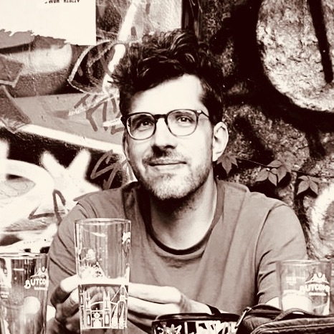
Aron Budinszky – Senior Application Developer
https://aron.budinszky.me/ | aron@budinszky.me
+49 1724620724 | Rheinsberger Str. 41 | 10435 Berlin, DE

profile
Throughout two decades of software development across a wide variety of languages and technologies reaching back to my early teen years, I have amassed a vast array of expertise regarding the art of coding, efficient development processes, and a resolute focus on end-user experiences – whether that be a client, a customer, or another fellow developer.

work experience
For a product portfolio, please take a look at https://aron.budinszky.me/

UNiDAYS – 2022-present – Berlin, DE; remote – lead iOS developer – Student discounts platform with millions of active iOS users. As the most senior member of a small iOS team, I have been overseeing the modularization and modernization of our codebase all while delivering A/B testable new features to ensure continuous improvement. A testament to our success has been the incredibly high App Store rating, a consistently low crash rate, and our ability to deliver features that boosted key business metrics.

Neofonie Mobile – 2018-2022 – Berlin, DE – lead iOS developer – Berlin-based agency delivering quality apps for mid- to large- German companies. Among many others, I worked on apps for ADAC, HUK Coburg, and Rademacher. I dealt with many different processes, tech stacks, and corporate environments. Most of our projects were native iOS (Swift), but I also worked on cross-platform projects (Flutter), but have extensive experience with supporting tasks such as managing build infrastructure or helping to design an optimal API.

KatalystFP Particimint – 2013-2017 – Berlin, DE & New York, USA – partner, lead developer – Syndication platform to help investors track their deals using a variety of tools including detailed reports and access to a secure API. I originally joined the project when KatalystFP became a client of my company, later became a fully-fledged partner and lead developer of the startup platform. The project was web-development focused with much of the heavy-lifting done with complex SQL Server queries.

Outlast Web & Mobile – 2012-2018 – Budapest, HU & Berlin, DE – founder, code architect, iOS developer – Software development services company I founded. We focused on developing websites and mobile applications for ad agencies, publishers, and startups. We had a team of 8 people designing, developing, and supporting a number of projects. I gained experience in leadership and acquired the know-how and focus required for managing cost-effective and on-time project delivery.

Next Wave Europe – 2010-2012 – Budapest, HU – lead developer, iOS developer – Social media marketing agency. My tasks included planning and implementing social media and web applications that engage customers and build brand loyalty. I worked on campaigns for top international brands such as Nike, Jägermeister, Loreal, etc. Inevitably my job was intertwined with the creative side of product dev.

Other employers and projects – 1998-2010 – Budapest, HU & Austin, USA – My previous programming experience includes working for DrNatura (developing online marketing and custom online shop for selling supplements), Bookaband.com (booking local musicians for weddings and events), and Zajlik (I was founder and developer of what became the largest alternative music website in Hungary in the early 2000s).

education
University of Texas – BA in Economics and Political Science – 2005
University-level offline and online courses in software development – C++ (2000, 2023), Java (2004), SQL (2010), Objective C (2012), Swift (2017), Flutter (2019), SwiftUI (2021), Kotlin (2022)

technologies
Mobile – Swift (advanced), Objective-C (advanced), Kotlin Multiplatform (advanced), Flutter / Dart (intermediate)
Database – Core Data (advanced), MySQL (advanced), SQL Server (advanced), NoSQL (advanced)
Networking – Multithreaded API access (advanced), secure APIs (advanced)
Web – Server-side Swift (advanced), PHP (advanced), JavaScript (advanced)
API – iOS/macOS APIs (advanced), Social APIs (advanced), OAuth flows (advanced), custom APIs (advanced)
Concepts – MVC, MVVM, VIPER, & clean arch. (advanced), OOP (advanced), TDD (advanced), FRP & Rx (intermediate), Agile (advanced), GTD (advanced)
Others – CI (advanced), Bash (advanced), Java (intermediate), Perl (intermediate), C++ (intermediate), Linux (intermediate), AWS (intermediate), Python (basics)

open source contributions
I have always been a strong believer in contributing to the OSS community. Apart from open-sourcing many of the libraries and frameworks my company built, I also contributed to many existing projects. Some of my contributions:

World Lecture Project – (Full stack, Server-side Swift + Vue.js; project leader, main contributor) – WLP is a non-profit organization centered around collecting and archiving academic videos. I built the full web tech as a side-project, parts of which are open-sourced.

Outlast Framework – (PHP, MySQL, JS; project leader, main contributor) – custom-built MVC web framework designed specifically for the unique workflow of development agencies, enabling enhanced modularity and templating

MeiliSearch – (Swift; contributor) – Swift library for the open-source search engine -

Material Components iOS – (Objective C; contributor) – Google’s Material Design library for iOS apps; contributed bugfixes

Sequel Pro – (Objective C; contributor) – a fast, easy-to-use macOS-based MySQL database management application; contributed fixes and features

And others: https://github.com/aronbudinszky

personal projects
PushKin Standalone – (Swift, iOS app) – connects to Ableton’s Push 3 Standalone and lets the user manage files directly from their phone.

iOS Audio Units – (C++, Swift) – Currently learning how to create AU3 plugins for iOS and building a project around it.

community contributions
Articles on Medium, reputable StackOverflow profile, wiki/blog with solutions to common issues, active member in Vapor Discord and LGBTQ in Tech.

languages & citizenship
Native speaker in English and Hungarian
Approx. B2 level, with ongoing studies in German

I am a dual-citizen of EU (Hungary) and the US and a resident of Berlin since 2015.

interests
Apart from tech, I enjoy debating about current political and economic events. I am an avid music fan and artist, with a specific focus on electronic music. My international background has inspired me to adopt an objective approach and embrace diverse ideas.

